Wire Frame Model
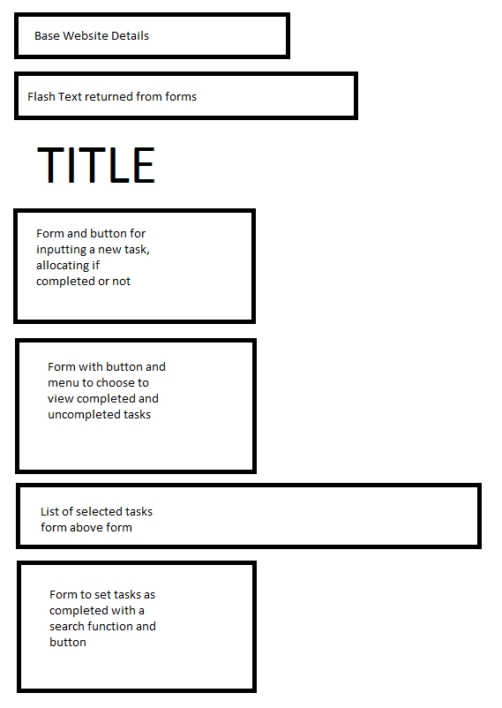
The layout is a simple set of forms in an intuitive order, the base html data is listed at the top of the page as the new html generated is an extension. The flash returned data is also marked at the top as this will change with important information and so should be easy to locate.
The forms are in an order so for when beginning to use the application, without using the prior (higher) form first the form below Is becoming almost invalid, due to the user or database not having the knowledge needed.
The models implemented in the web application are simply the database model. Which is referenced to store the data of each task: ID, name, and if the task has been completed or not.
Overall the implementation of all the tasks required has been met. Using the database in a particular way so that it uses the models complicated the nature of the assignment a little, so that it would have been much more complicated to design the final form to show a list of unfinished tasks to choose to be completed rather than simply the user having to type in the exact name of the task.
And even when a task is changed and it’s not actually changed it still says it is, though the difference can be indicated by the fact that there is no ID of the task shown when it’s not been altered.

